Tentative Schedule for Geology 192/Anthropology 192

June 26: Students meet at hotel by 5 PM. Pick up rental vans during day and shuttle students from airport if necessary. Evening orientation meeting. Hampton Inn, Renton, WA

June 27: Renton to Olympic Peninsula and Olympic National Park, with stops at Dungeness Bay and Hurricane Ridge. Red Lion Inn, Port Angeles, WA

June 28: Lake Crescent, and Sol Duc Rainforest in Olympic National Park. Ozette, Neah Bay and Cape Flattery of the Makah Nation. Red Lion Inn, Port Angeles, WA

June 29: Take ferry to Victoria on Vancouver Island. Exploration of Beacon Hill Park, Pt. Finlayson, Mt. Douglas, Shaw Center for the Salish Sea. Accent Inn, Victoria BC.

June 30: East Sooke Regional Park and petroglyphs, Sooke Potholes. Accent Inn, Victoria, BC.

July 1: Goldstream Provincial Park, Duncan Totems, Nanaimo Petroglyphs, Nanaimo Coal Mining. Take ferry to Horseshoe Bay. Holiday Inn, North Vancouver, BC.

July 2: Museum of Vancouver and Museum of Anthropology at University of British Columbia. Frasier River delta. Holiday Inn, North Vancouver, BC.

July 3: Sea to the Sky Highway: Brunswick Beach, Porteau, Britannia Beach, Shannon Falls, Squamish Chief dome. Sandman Motel and Suites, Squamish, British Columbia

July 4: Britannia Copper Mine museum and tour, Brandywine Falls. Sandman Motel and Suites, Squamish, British Columbia

July 5: Whistler Winter Olympics Venue, Sea to Sky Gondola, Black Tusk and Mt. Garibaldi volcanoes. Listel Hotel, Whistler, BC

July 6: Xwisten archaeology tour, Goldpan Provincial Park. Best Western, Merritt, BC

July 7: Okanagon Valley, return to United States Best Western Plus, Omak, WA
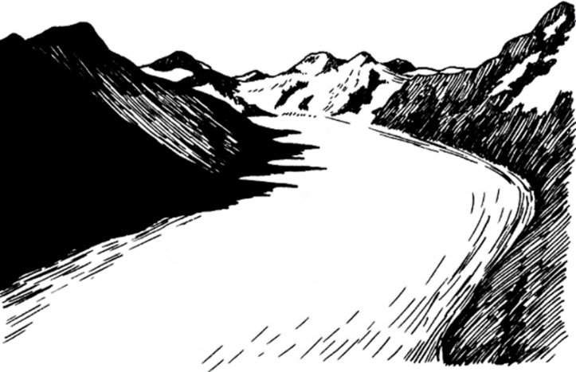
July 8: Grand Coulee Dam, Channeled Scablands, Spokane Flood, Dry Falls State Park, Lake Chelan. Best Western, Omak, WA

July 9: Washington Pass, Ross Lake, North Cascades National Park, Mt. Baker Volcano. Fairfield Inn, Burlington WA

July 10: Return to SeaTac for car pick up and airport shuttle.

