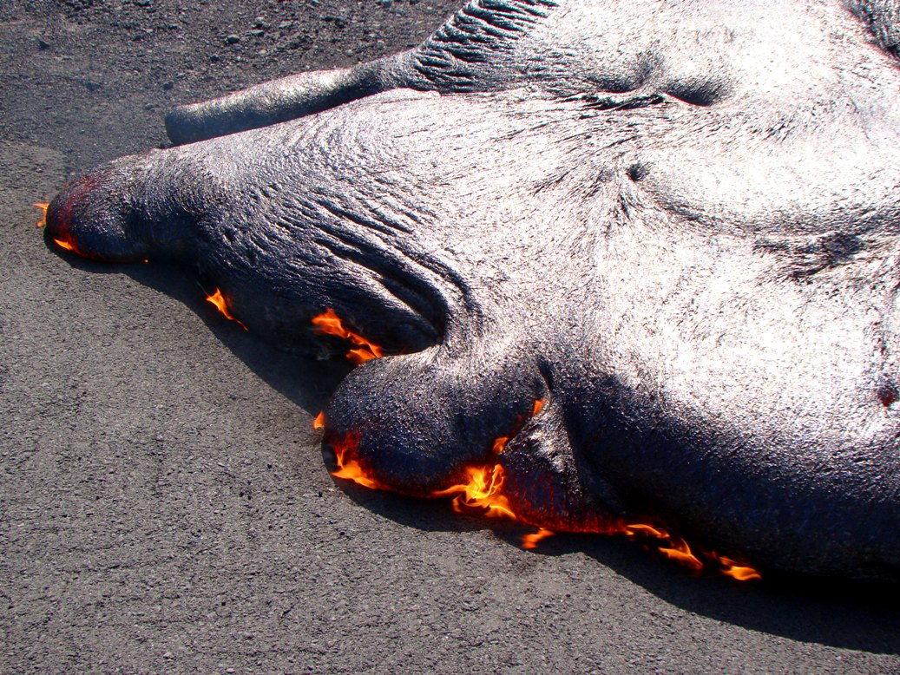  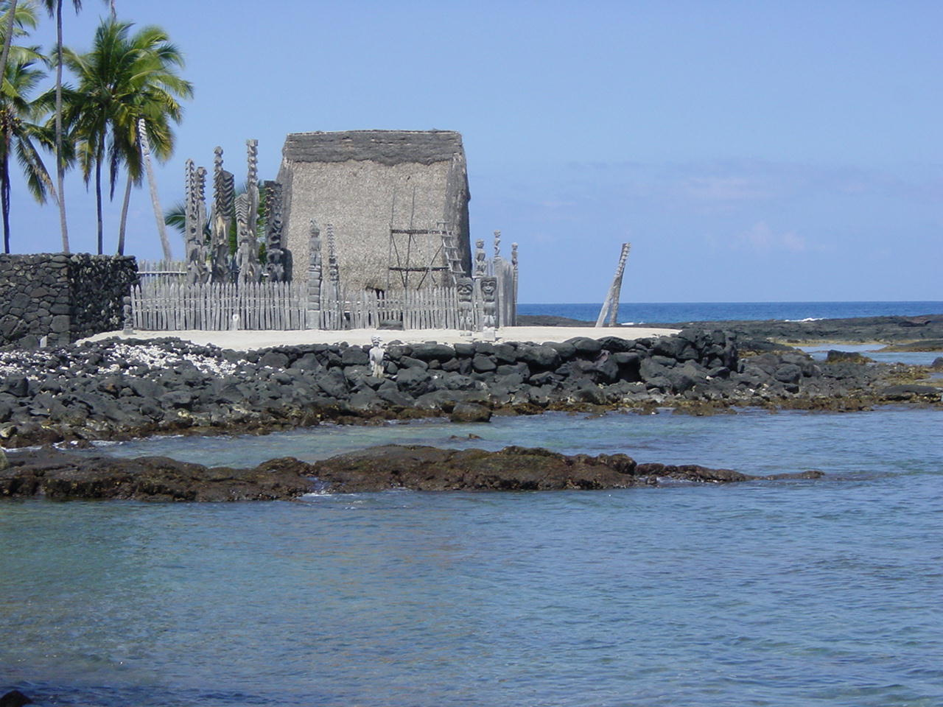 |  |  | Join us in a unique tour of two of Hawaii's most diverse islands to explore a variety of incredible geological and archaeological sites!  Some Highlights:  Hawaii (Big Island)  Hawai’i Volcanoes National Park  Kilauea Iki Crater  Lyman Historical Museum, Hilo  Pu’ukohala Heiau and Kohala Petroglyphs  Tsunami Museum in Hilo  Pu’uhonue o Honaunau National Historical Park  Island of Kauai  Pali Coast and Na Pali Overlook  Hanalei Bay and Ke’e Beach  Waimea Canyon-Grand Canyon of the Pacific  Old Koloa Town / Koloa Heritage Trail  Contact Us  Phone: [Telephone]  Email: [Email address]  Web: [Web address]  Instructors  Dr. Susan Kerr, Professor of Anthropology, Modesto Junior College (kerrs@yosemite.edu)  Garry Hayes, Professor of Geology, Modesto Junior College (hayesg@yosemite.edu)  Hawaii Field Studies in Geology and ANthropology June 1-13, 2016 Two courses in one!  [Address]  [City, ST ZIP Code] |  |  | Hawaii Field Studies in Geology and ANthropology June 1-13, 2016 Two courses in one!  - Modesto Junior College

For more information:  Dr. Susan Kerr, Modesto Junior College (kerrs@yosemite.edu)  Garry Hayes, Modesto Junior College (hayesg@yosemite.edu)  Website: http://hayesg.faculty.mjc.edu/Hawaii_2016.html  Facebook Page: https://www.facebook.com/groups/452708258272005/ |  |  | Trip participants will receive six semester credits as students in Anthropology 190 and Geology 190, enrolled through Modesto Junior College (http://www.mjc.edu/).  Getting there and back:  Participants will meet the professors in Hilo, HI on June 1, 2016 and travel with the group for 13 days.  Students will make their own arrangements to get to Hilo, and return home from Lihue, Kauai.  Participants may choose to extend their trip by adding days on other islands either before June 1 or after June 13.  Getting around the islands:  We will use rental vans.  An Inter-island flight from Kailua-Kona, Big Island to Lihue, Kauai will be pre-arranged for the group.  Accommodations:  All hotel accommodations will be booked for the group for dates June 1-13.  Mid-level lodging, double occupancy, 1 or 2 beds, we will try to honor participant’s preferences. |  |  | Nene, the state bird of Hawaii  Total Fees: $2,200  Fees include:  Inter-island flight, transportation, entrance fees and lodging  Additional Expenses for Students:  Airfare to and from the Hawaiian Islands (may range from $500 to $900)  Meals during the trip (est. $360-520)  Fees related to enrollment in both Geology 190 and Anthropology 190 (approximately $300).  Payment Schedule:  Due November 15, 2015 : $200 (deposit with registration form)  Due February 1, 2016: $500  Due April 22, 2016: $1,500

