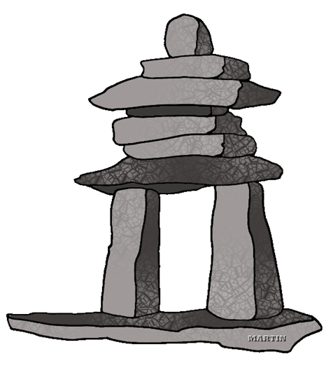
A Unique Learning Adventure!

Anthropology and Geology of the British Columbia, Alberta, and the Pacific Northwest:
Anthropology 192 and Geology 192

July 21-31, 2014

The western provinces of Canada and the northwestern American states contain some of the most spectacular geology to be found on the American continent. From the coastal mountain ranges of the Olympic Peninsula and Vancouver Island to the Rocky Mountains of Alberta and Montana, we will see an incredible record of far-traveled exotic terranes, and hints of the primordial beginnings of the North American continent.

The region was the pathway for human settlement of the Americas, and many diverse cultures continue to live in the region today.

MJC’s unique collaboration of field studies in geology and anthropology returns this summer with a joint field excursion out of Seattle that will explore the Olympic Peninsula and Vancouver Island, the Coastal Mountains of British Columbia, the Purcell Range, Banff and Jasper National Parks, and Glacier and Mt. Rainier National Parks in Montana and Washington. Join anthropology professor Susan Kerr and geology professor Garry Hayes on an eleven-day adventure through some of the most interesting landscapes and archaeological sites on the North American continent.

When and How? The group will come together in Seattle Washington on July 21st, and will return to Seattle on July 31st. We will travel in rental vans, and stay in hotels.

Costs? The trip will cost about $1,350, which includes transportation, admission fees, accommodations, and teaching materials. Students will be responsible for getting to and from Seattle, and for meals (many of the hotels offer free breakfasts, and some rooms will have microwaves). There will be the tuition costs for 3 units of semester credit for each class, and fees for getting or renewing a passport.
Accommodations? We are staying in a variety of motels and hotels ranging from urban to practically wilderness settings. We are assuming double occupancy for married couples, and double to triple occupancy for singles. We will try to accommodate requests for single rooms for a surcharge, but cannot guarantee it. (The earlier your request, the better the chance for getting extra rooms).

Academics: The field courses are worth three semester units each. Participants will be expected to keep field notes and to complete worksheets and quizzes during the trip, and to prepare informal presentations.

Passports: If you do not have a current passport, get started here: http://travel.state.gov/content/passports/english.html. Get going on this right away, as the process may take 4-6 weeks, and expedited requests can be expensive.

Burgess Shale Excursion: We are attempting to arrange a tour of this famous fossil locality, and there are some factors to consider: it is a fairly strenuous 10 mile hike with an elevation gain of 2,500 feet (but is also one of the most scenic trails you will ever see). A group tour must register between 10-12 people, and will cost about $65 per person. Please indicate on the form if you are interested in the tour, as we must make arrangements soon. If you don’t feel you can handle the hike, there is an equally spectacular day in store for those who don’t participate, exploring Yoho, Banff and Kootenay National Parks.

What’s next? Fill out the attached interest form so we can keep you informed of any developments (the form requires no commitment or payment). Official registration in the class at MJC begins on March 31st (go to https://www.mjc.edu/ for enrollment information). We will require the attached registration form with a deposit of $100 by April 21, 2014. Full payment is required by June 6, 2014 (most of group fees and expenses must be paid a month prior to our trip).

The Geology and Anthropology Clubs at MJC are working to raise funds to assist students with their fees for the trip. If you wish to request support, you need to join one club or the other and participate in some of the fundraisers (this is an ASMJC and MJC requirement). Please contact us for more information, or check with the club facebook page at https://www.facebook.com/groups/MJCGeologyClub/ .

More information: For more information, contact Garry Hayes (hayesg@mjc.edu or 575-6294) or Susan Kerr (kerrs@mjc.edu or 575-6107). The course website is at http://hayesg.faculty.mjc.edu/GeologyPacificNorthwest.html .

Tentative Schedule for Geology 192/Anthropology 192

July 21: Students meet in Seattle, and stay in a hotel near SeaTac Airport. Pick up rental vans during day and shuttle students from airport if necessary. Evening orientation meeting with students. Sleep Inn, SeaTac, WA

July 22: SeaTac to Olympic Peninsula and Olympic National Park, with trip to Hurricane Ridge, Ozette, Neah Bay and hence to Port Angeles. Take ferry to Victoria on Vancouver Island. Comfort Inn and Suites in Victoria, BC

July 23: Exploration of Victoria and north Vancouver Island. At end of day, we'll ferry from Nanaimo to West Vancouver. Holiday Inn in North Vancouver, British Columbia.

July 24: Follow Highway 99, the Sea to the Sky Highway to Whistler, then continue on 99 to Kamloops. Hampton Inn, Kamloops, British Columbia

July 25: Kamloops to Golden, via Revelstoke and Glacier National Parks (the Canada version of Glacier), Holiday Inn Express in Golden, British Columbia

July 26: Explore out of Golden. One group will pay extra fee for Burgess Shale hike ($65, student rate, we can arrange for a minimum group of 10 students). Others will tour Yoho, Kootenay, and Banff National Parks. The Juniper Hotel in Banff, Alberta

July 27: Explore out of Banff. Head to Lake Louise and north to the Athabasca Glacier and Columbia Icefield. Proceed to Drumheller, Alberta. Super 8 Hotel in Drumheller, Alberta

July 28: Visit the Royal Tyrell Museum in Drumheller, explore Dinosaur Fossil sites outside Drumheller, head south and west over Crowsnest Pass and Frank Slide, visit Head-Smashed-in-Buffalo-Jump, then to Pincher Creek. Possible visit to Kootenai Brown Pioneer Village. Ramada, Pincher Creek, Alberta

July 29: Explore Waterton National Park, then return to U.S. and explore Glacier National Park. Best Western Flathead Lake in Kalispell, MT
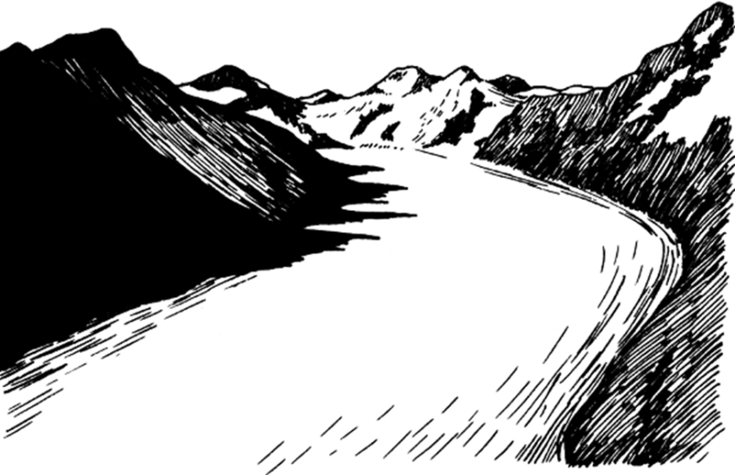
July 30: Evidence of the Spokane Floods, Camas Prairie, Channeled Scablands, Dry Falls, and Grand Coulee. Ramada Inn, Moses Lake WA

July 31: Mt Rainier National Park, then back to Tacoma/SeaTac. Return to Sleep Inn Hotel in SeaTac for car pick up and airport shuttle.

Modesto Junior College Registration Form
Geology 192 or Anthropology 192: Geology of the Pacific Northwest

Personal Information
Last Name | First Name |  | M.I.
Address
City |  | State | Zip Code
Home Telephone |  | Cell Phone
E-mail Address
Emergency Contact (during course) |  | Telephone

Rooming and Additional Options: Please fill in all that apply

I am traveling with my spouse/partner and prefer to room together:
(typically a single queen bed)
I am traveling with these other family members:
(typically two double or queen beds)
I am over 21 and wish to pay a surcharge for a single room (where available)

I will share a room with another 1-2 other students.

Total Fees: $1,350

Fees include:
Transportation and fuel (van rentals)
Lodging (assuming double occupancy; fee will vary for other arrangements)
Entrance to museums, parks and other overhead expenses (does not include Burgess Shale tour)
Please check here if you wish to attend the Burgess Shale excursion (extra cost, see below)

Participants are responsible also responsible for:
Airfare or driving costs to and from Seattle, Washington
Passport fees
All meals during the trip (some motels include free breakfast)
MJC enrollment in Geology 192 or Anthropology 192 enrollment: $46/ unit, plus $15 health fee

Payment Schedule:
Due April 21, 2014 (deposit due with registration form): $100
If attending the Burgess Shale tour, $65 is due with the deposit
Remaining balance due June 6, 2014 $1,250

Yes! I'm interested. Please send more information:

Name: .

Address: .

City: State: Zip: .

Telephone and e-mail: .

Send to: Garry Hayes or Susan Kerr, Modesto Junior College, 435 College Ave., Modesto CA 95350 , or e-mail: hayesg@mjc.edu or kerrs@mjc.edu

